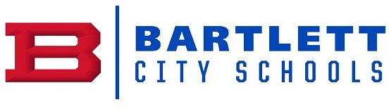
Physical Science Curriculum Guide Q4

TN Ready | Learning Target | Resources  Supplemental
Thermal Energy, Ch. 6
3202.2.3 Examine the applications and effects of heat energy. | Collect data to determine what happens when warm and cold objects touch each other.  Compare the ability of selected materials to absorb and/or radiate thermal energy.  Classify heat transfer as conduction, convection, or radiation.  Solve problems regarding heat, mass, specific heat capacity, and temperature change (Q=mCΔT). | Heat Activities  (Includes:  Heat, Temperature & Conduction  Evaporation  Condensation  Freezing  Melting)  Hot and Cool Lab
TN Ready | Learning Target | Resources  Supplemental
Energy Sources, Ch. 9
3202.2.11 Research he importance of energy conservation.  3202.2.12 Explore nuclear energy and its impact on science and society. | Discuss properties and uses of fossil fuels.  Describe advantages and disadvantages of using nuclear energy to produce electricity.  Compare the advantages and disadvantage of various alternate energy sources. | Renewable Energy Project  Field Trip to Solar Farm at the Agricenter
TN Ready | Learning Target | Resources  Supplemental
Mechanical Waves and the Electromagnetic Spectrum, Ch. 12
3202.2.1 Investigate the properties and behaviors of mechanical and electromagnetic waves. | Investigate the properties of waves using a variety of wave makers, such as ropes and springs.  Investigate and distinguish between the relationship between wavelength and frequency and amplitude.  Classify waves as transverse or longitudinal.  Distinguish between mechanical and electromagnetic waves. | Cosmic Colors Activities  Flinn Build Your Own Spectroscope  CPO Activities
TN Ready | Learning Target | Resources  Supplemental
Light and Optics, Ch. 13
3202.2.2 Explore and explain the nature of sound and light energy. | Investigate factors that affect the speed of sound and compare and contrast sound and light waves.  Use print and electronic resources to investigate the use of active noise reduction technology.  Design and conduct an investigation of wave interactions while distinguishing among wave reflection, refraction, diffraction, and interference. | !3-1 and 13-2 ppt and notes  13-3 and 13-4 ppt and notes  Exploring Light and Color Video  Law of Reflection Illustration Activity  Matter, Optics and Bubbles Activity  Seeing the Light – The Eye Video  Eye Diagram Flip Chart  Eye Dissection  Ch. 13 Review and Test
TN Ready | Learning Target | Resources  Supplemental
Family Life Curriculum
 |  | Teacher to use Curriculum determined by the Bartlett City Schools (Middle School Only).

