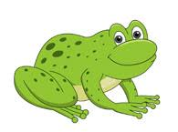

someone who studies reptiles and amphibians

herpetologist

Frogs

Frogs

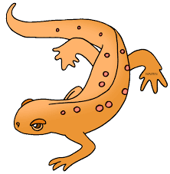

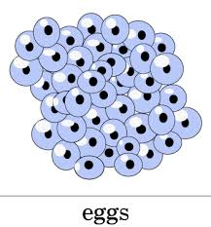

a floating clump of frog eggs

spawn

Frogs

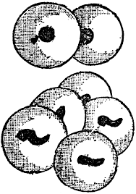

in the earliest stages of growth

embryos

a part of the tadpole’s body used to obtain oxygen from water

Frogs

gills

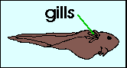

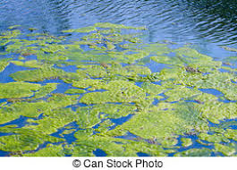

a plant-like organism that has no stems or leaves, and grows in water

Frogs

algae

Frogs

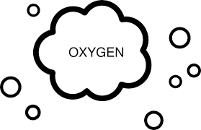

a chemical element necessary for life

oxygen

Frogs

to swell or curve outward

bulges

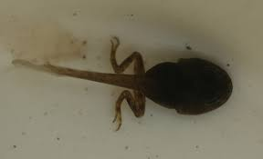

bulge

vegetarians

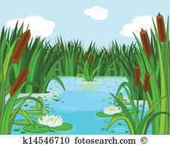

only eat plant life

Frogs

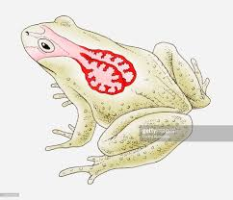

lungs

the main breathing structure inside animals that help the body obtain oxygen

Frogs

Frogs

shed

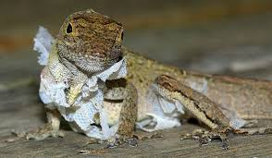

to cast off

amphibian

* can live on land or on water
* comes from a Greek word that means “two lives”

Frogs

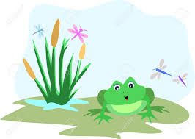

cold-blooded

inside body temperatures are about the same as the outside temperature

Frogs

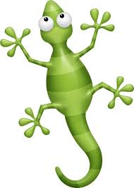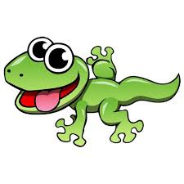



Frogs

transparent

can be seen through

Frogs

camouflage

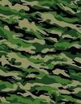

skin color can hide them from enemies

Frogs

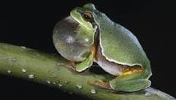

a rapid motion back and forth, or side to side

vibrate

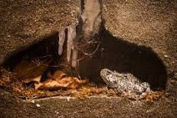

to sleep through winter

hibernation

Frogs